Data Science Laboratory – R Programming

Subject Code: DMC6311

|  |  |
| --- | --- |
| Name | Haryish E |
| Degree and Batch | MCA – Batch 1 |
| Roll No | 2232MCA0058 |

INDEX

1. Calculate the number if occurrence of a character in each row of R DataFrameCalculate the number if occurrence of a character in each row of R DataFrame. 2

2. Find row and column index of the maximum and minimum value in a matrix in R 4

3: Multiply a matrix by its transpose while ignore missing values in R. 6

4. Remove rows with NA in one column of R DataFrame. 7

5. How to find common rows and columns between two dataframe in R? 8

6. Adding Colors to Charts in R Programming. 10

7. Create a Stacked Dot Plot in R. 11

8. Plot Shaded Area between vertical lines in R. 12

9. Add Mean and Median to Histogram in. 13

10. Create Scatter plot from CSV in R. 14

# 1. Calculate the number if occurrence of a character in each row of R DataFrameCalculate the number if occurrence of a character in each row of R DataFrame.

**Program**:

# Sample DataFrame

df <- data.frame(

ID = 1:5,

Text = c("hello", "world", "foo", "bar", "baz")

)

# Character to count

char_to_count <- "o"

# Function to count occurrences of a character in a string

count_char <- function(text, char) {

sum(strsplit(text, "")[[1]] == char)

}

# Apply the function to each row of the DataFrame

df$Occurrence <- apply(df, 1, function(row) count_char(row["Text"], char_to_count))

# Output DataFrame with occurrences of the character

print(df)

**Output**:

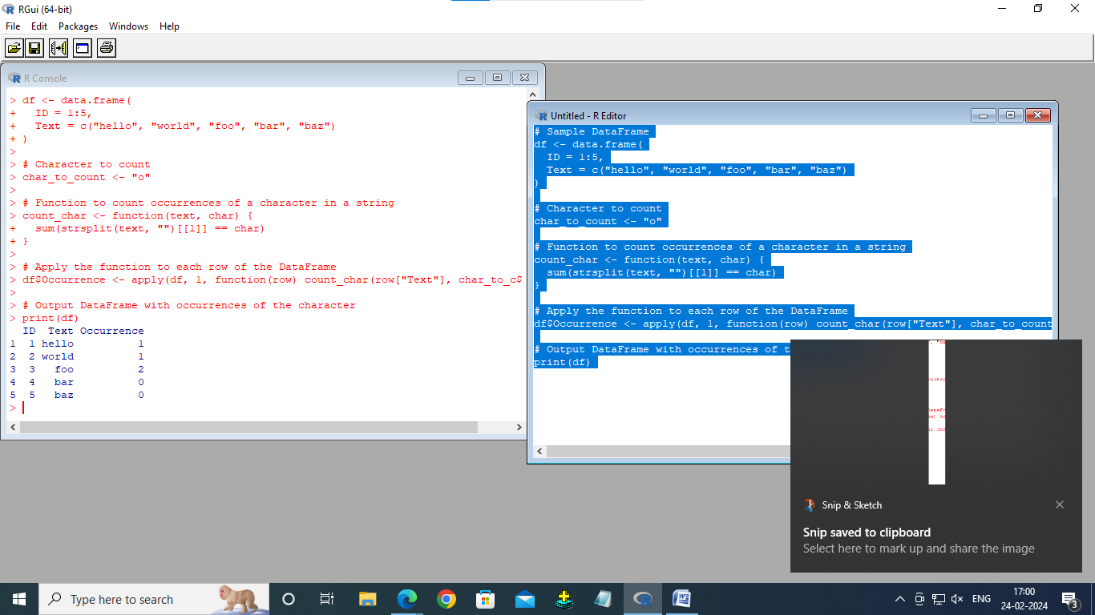

# 2. Find row and column index of the maximum and minimum value in a matrix in R

**Program**:

# Create a sample matrix

mat <- matrix(c(1, 2, 3, 4, 5, 6, 7, 8, 9), nrow = 3, byrow = TRUE)

print(mat)

# Find the row and column index of the maximum value

max_index <- which(mat == max(mat), arr.ind = TRUE)

max_row <- max_index[1, 1]

max_col <- max_index[1, 2]

# Find the row and column index of the minimum value

min_index <- which(mat == min(mat), arr.ind = TRUE)

min_row <- min_index[1, 1]

min_col <- min_index[1, 2]

# Print the results

cat("Maximum value:", max(mat), "at row", max_row, "and column", max_col, "\n")

cat("Minimum value:", min(mat), "at row", min_row, "and column", min_col, "\n")

**Output**:

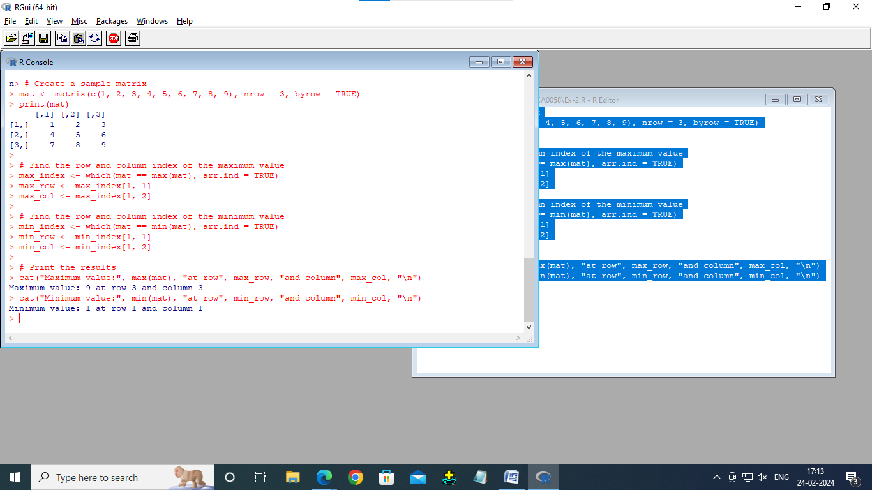

# 3: Multiply a matrix by its transpose while ignore missing values in R.

**Program**:

multiply_matrix_transpose <- function(mat) {

mat <- na.omit(mat)

result <- mat %*% t(mat)

return(result)

}

example_matrix <- matrix(c(1, 2, 3, 4, 5, 6, 7, 8, 9), nrow = 3, byrow = TRUE)

result <- multiply_matrix_transpose(example_matrix)

print(result)

**Output**:

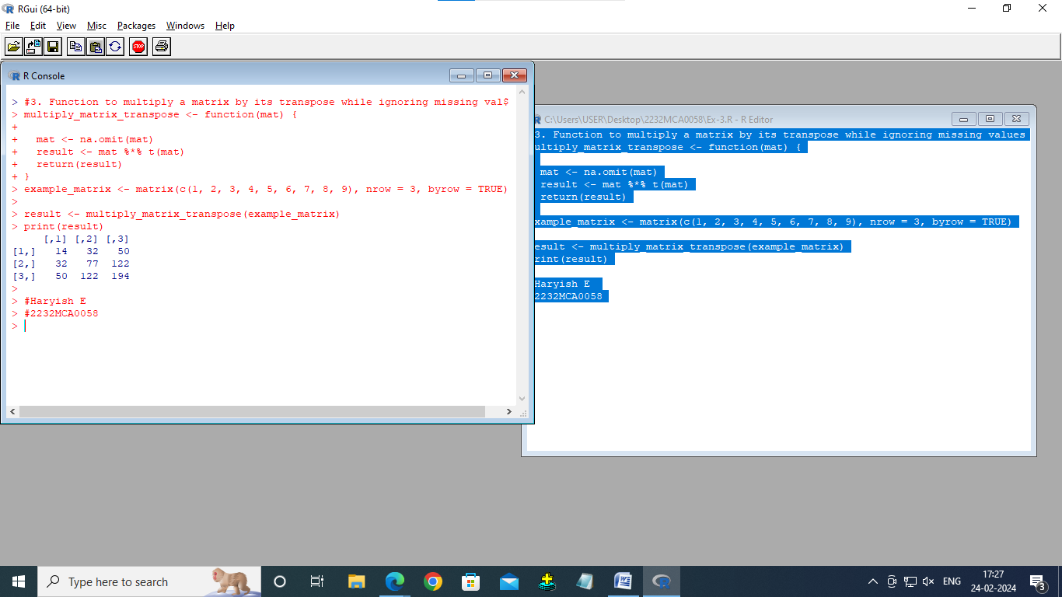

# 4. Remove rows with NA in one column of R DataFrame.

**Program**:

# Create a sample DataFrame

df <- data.frame(

col1 = c(1, 2, NA, 4),

col2 = c(5, NA, 7, 8)

)

print(df)

# Remove rows with NA values in col1

df_filtered <- df[complete.cases(df$col1), ]

print(df_filtered)

**Output**:

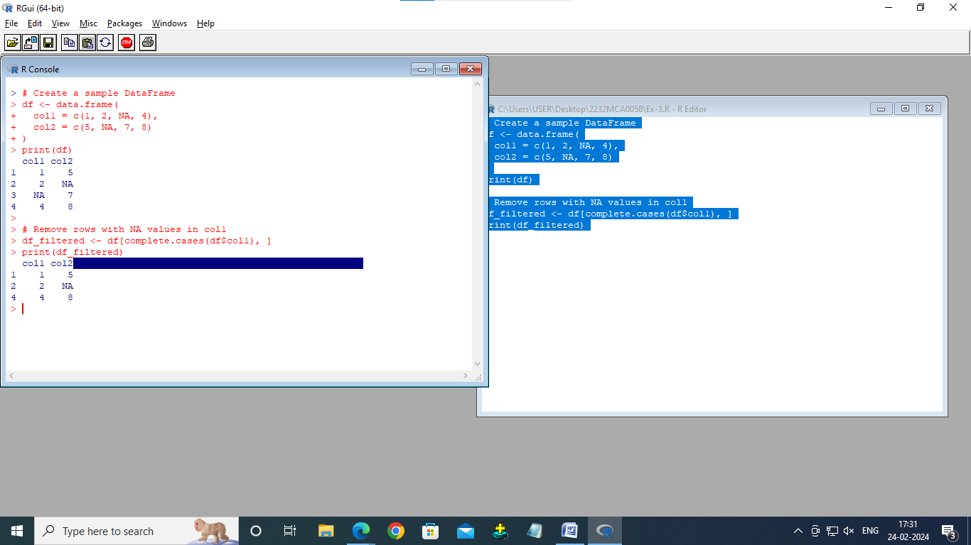

# 5. How to find common rows and columns between two dataframe in R?

**Program**:

# Create sample dataframes

df1 <- data.frame(A = c(1, 2, 3), B = c(4, 5, 6))

df2 <- data.frame(A = c(2, 3, 4), B = c(5, 6, 7))

# Find common rows

common_rows <- intersect(rownames(df1), rownames(df2))

# Find common columns

common_cols <- intersect(names(df1), names(df2))

print("Common rows:")

print(common_rows)

print("Common columns:")

print(common_cols)

**Output**:

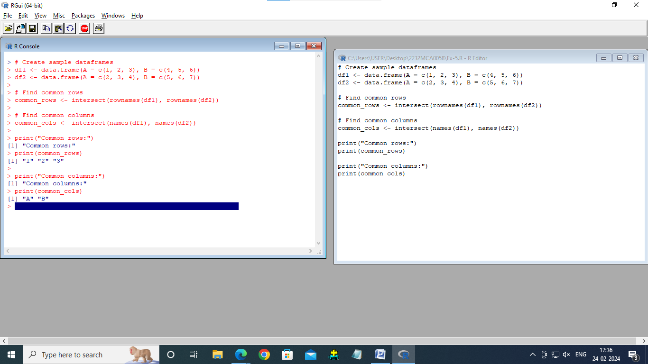

# 6. Adding Colors to Charts in R Programming.

**Program**:

# Create a simple plot with colors

x <- 1:10

y <- x^2

# Plot with colors

plot(x, y, col = "blue", main = "Plot with Colors", xlab = "X", ylab = "Y")

**Output**:

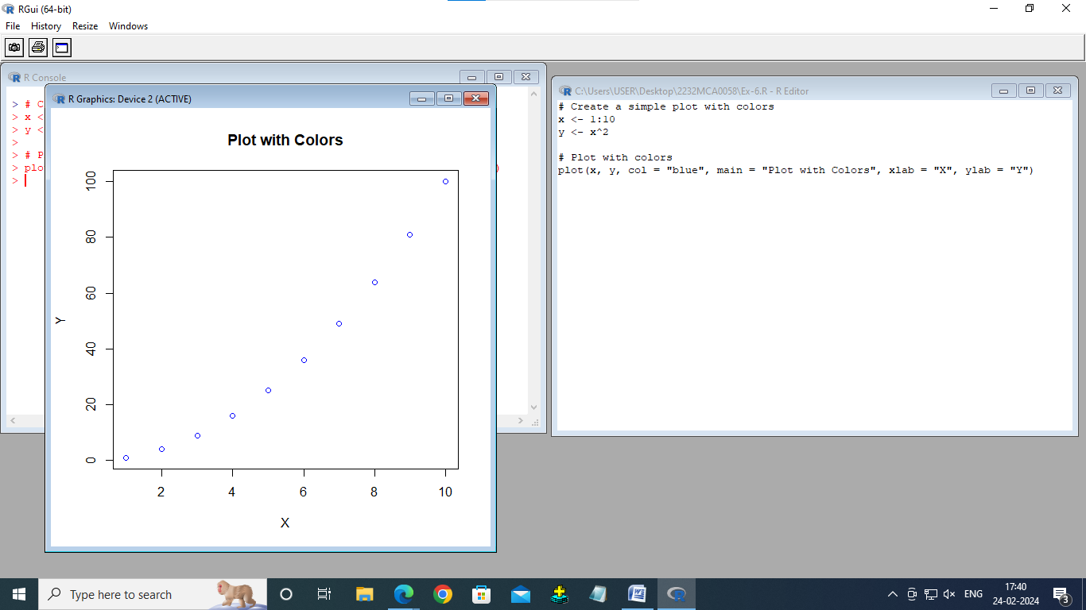

# 7. Create a Stacked Dot Plot in R.

**Program**:

# Create sample data

data <- data.frame(Category = c("A", "B", "C"),

Value1 = c(10, 20, 30),

Value2 = c(15, 25, 35))

# Stacked dot plot

dotchart(t(data[-1]), main = "Stacked Dot Plot", xlab = "Value", ylab = "Category", color = c("red", "blue"), pch = 19, labels = rownames(data))

**Output**:

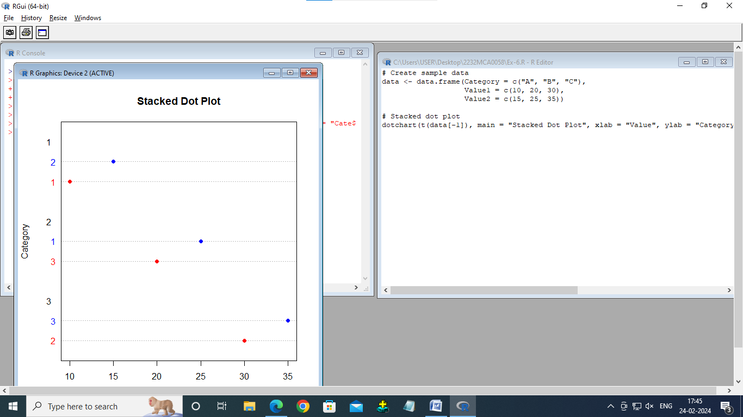

# 8. Plot Shaded Area between vertical lines in R.

Program:

# Create sample data

x <- 1:10

y <- sin(x)

# Plot shaded area

plot(x, y, type = "l", ylim = c(-1, 1), xlab = "X", ylab = "sin(X)")

polygon(c(2, 2, 4, 4), c(-1, 1, 1, -1), col = "gray", border = NA, alpha = 0.3)

Output:

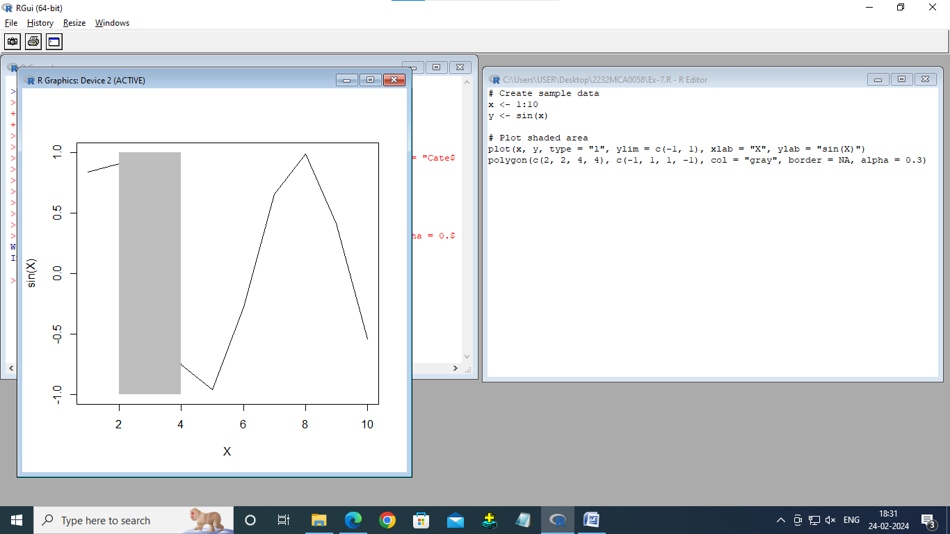

# 9. Add Mean and Median to Histogram in.

**Program:**

# Create sample data

data <- rnorm(100)

# Histogram

hist(data, main = "Histogram with Mean and Median", xlab = "Value", ylab = "Frequency")

abline(v = mean(data), col = "red", lwd = 2)

abline(v = median(data), col = "blue", lwd = 2)

legend("topright", legend = c("Mean", "Median"), col = c("red", "blue"), lty = 1, lwd = 2)

**OutPut:**

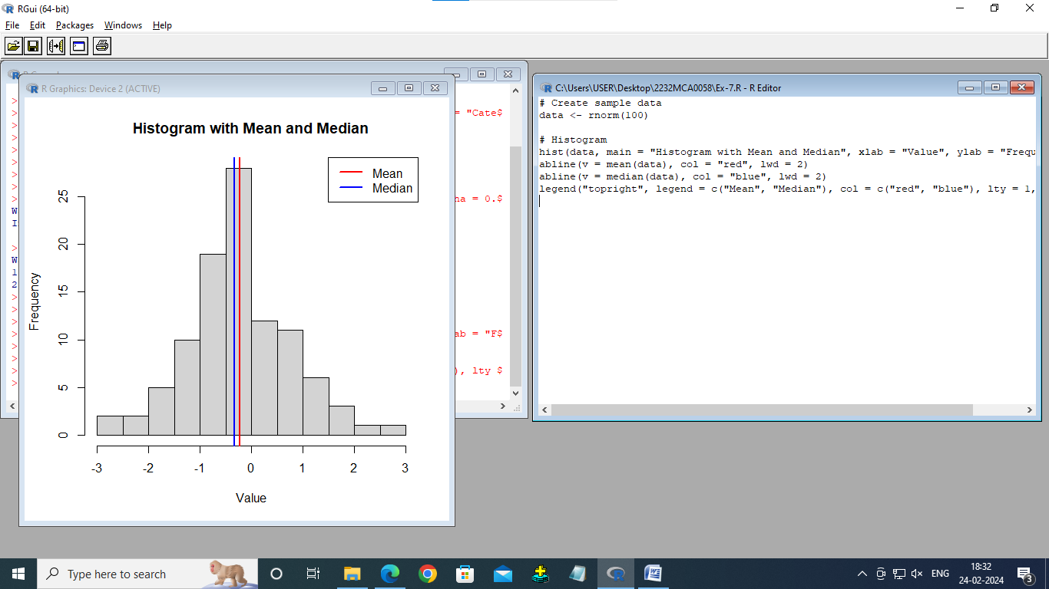

# 10. Create Scatter plot from CSV in R.

**Program:**

data <- read.csv("C:\\Users\\USER\\Desktop\\2232MCA0058\\data-Ex-10.csv")

# Create scatter plot

plot(data$X, data$Y,

main = "Scatter Plot",

xlab = "X-axis",

ylab = "Y-axis",

col = "orange",

pch = 19,

cex = 1.5)

**Output:**

